**Kubernetes**

* **What is Kubernetes?**

Open-Source Container Orchestration tool by google used to multi-Environment, multi–Container Deployment.

Orchestration: - means we can manage our front-end, back-end and database containers

Very easily without any downtime they work together.

* **Why do we use Kubernetes?**

For production ready deployment for micro services and small apps.

Heaving less failure and downtimes.

Backups and restore.

Kubernetes is very famous tool for manage micro services applications it manages small apps and orchestrate all the containers together.

* **Kubernetes Architecture and it’s Components:**

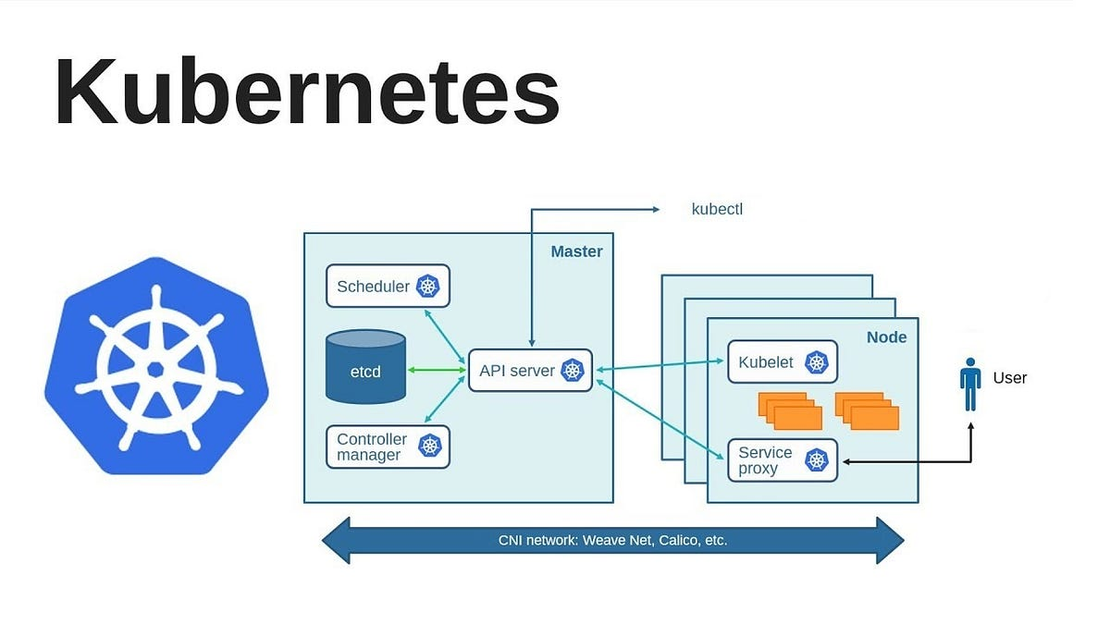

* **What is cluster?**
* Group of servers called cluster like we have master and worker nodes all are separate servers and working in same group.

**In above image we can see Kubernetes cluster divided into two parts: master and worker nodes.**

**Master** – work like manager and manages all the worker nodes operation. Runs only configuration files and scheduling, ETCD database etc. in separate server.

**Worker** – where the applications are running actually.

1. Control Plane (Master node)

Inside control plane we have 5 major components which is use to perform operations in worker nodes the components are:

1. API Server – Entrypoint of K8s cluster. (Application Programable Interface) one of the most important feature in master node because it manages all the worker node. We can use its services with the help of one tool which is “kubectl ” .
2. Scheduler- using for schedule the job. For Example, if we have newly created pod that have no node assigned then the scheduler becomes responsible for finding the best node for the pod to run on. First it gets the configuration of Hardware from configuration file and schedule the pod on nodes accordingly.
3. Controller Manager- continuously ensure that all pods are working properly and desire states are present all time. They watch the current cluster state and stored in ETCD database. Gather the information from API server and create, update, delete resources as necessary.
4. ETCD Database- ETCD is a database which stores all the data related with pod and node like secrets, config-maps, accounts, roll binding, replica controller, replica set etc.
5. Data Plane (worker nodes):
6. Kubelet: it is a component of worker node and work like agent. Perform all task given by API server inside worker node and collect all the information about node like health, condition, errors and inform to API Server.
7. Kube-proxy: the main work of kube proxy is create communication between pods suppose you deploy two pods one for front-end and one for database and both pod deployed on different nodes then kube proxy is responsible for communication between them.
8. CNI Network – (Container Network Interface) CNI is a framework or library use to internally

Network connectivity means proper communication between master node and worker node .

* **What is Difference between Node and Pod?**

Node is a server where pods are deployed. A node can contain multiple pods.

Pod is basically a single smallest unit of Kubernetes. Which is use to run our applications. Suppose you are running front end application then pod will create and handle its container itself.